Dean Smith

CS200

Homework #17

1.

|  |  |  |
| --- | --- | --- |
| **Current State** | **Transition on 0** | **Transition on 1** |
| Empty | empty | 1 |
| 1 | Empty | 11 |
| 11 |  |  |
|  |  |  |

Regular expression: {

2.

|  |  |  |
| --- | --- | --- |
| **Current State** | **Transition on 0** | **Transition on 1** |
| Empty | LOSE | 1 |
| 1 | LOSE | 11 |
| 11 | LOSE | 111 |
| 111 | 1110 | 111 |
| 1110 | 11100 | 111 |
| 11100 |  | 111 |
|  |  | 111 |
| LOSE | LOSE | LOSE |

Regular expression: {

3.

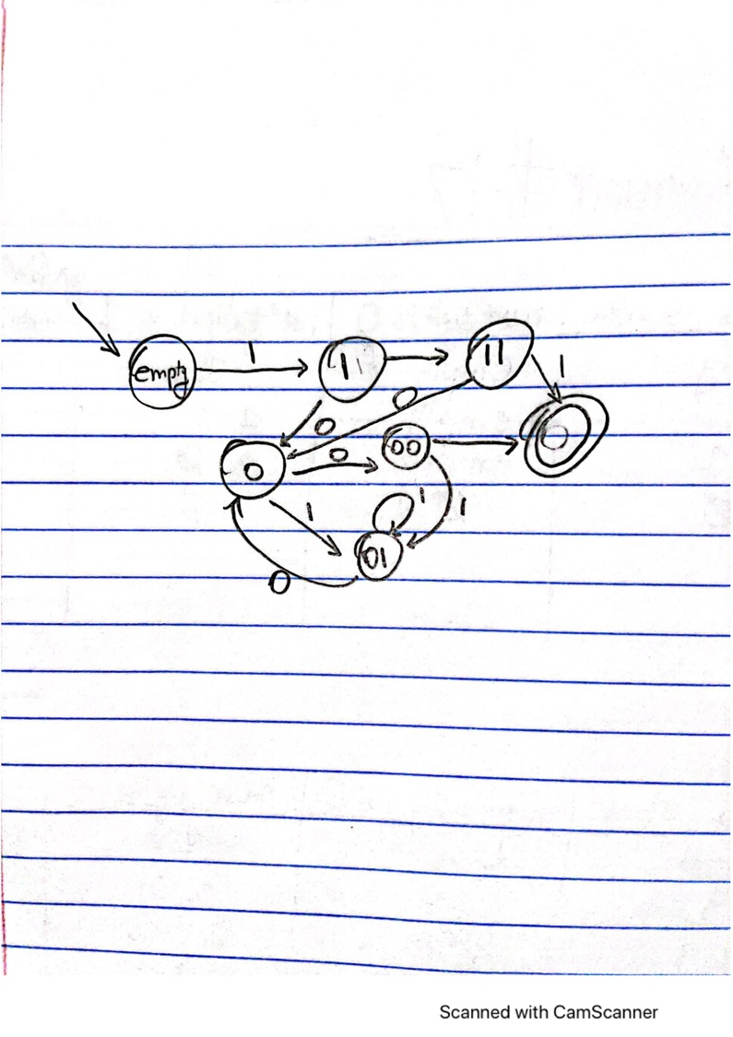

Regular expression: {